PIZZA SALES SQL QUERIES
KPI’s
1.Total Revenue -
SELECT SUM(total_price) FROM pizza_sales;

2.Average Order Value –
SELECT (SUM(total_price) / COUNT(DISTINCT order_id)) AS Avg_order_Value
FROM pizza_sales;
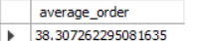
3. Total Pizzas Sold
SELECT SUM(quantity) AS Total_pizza_sold FROM pizza_sales;
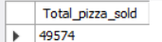
5. Average Pizzas Per Order
SELECT CAST(CAST(SUM(quantity) AS DECIMAL(10,2)) /
CAST(COUNT(DISTINCT order_id) AS DECIMAL(10,2)) AS DECIMAL(10,2))
AS Avg_Pizzas_per_order
FROM pizza_sales;
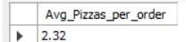
B. Daily Trend for Total Orders
SELECT DAYNAME(STR_TO_DATE(order_date, '%d-%m-%Y')) AS order_day,
COUNT(DISTINCT order_id) AS total_orders
FROM pizza_sales
GROUP BY DAYNAME(STR_TO_DATE(order_date, '%d-%m-%Y'));
Output:
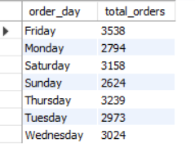
C. Monthly Trend for Orders
select monthname(str_to_date(order_date , '%d-%m-%Y')) as Month_Name, COUNT(DISTINCT order_id) as Total_Orders
from pizza_sales
GROUP BY Month_Name
ORDER BY Total_Orders DESC;
Output
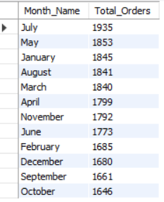

D. % of Sales by Pizza Category
SELECT pizza_category, CAST(SUM(total_price) AS DECIMAL(10,2)) as total_revenue,
CAST(SUM(total_price) * 100 / (SELECT SUM(total_price) from pizza_sales) AS DECIMAL(10,2)) AS PCT
FROM pizza_sales
GROUP BY pizza_category;
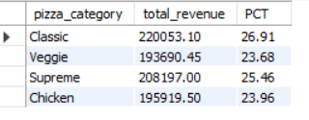
E. % of Sales by Pizza Size
SELECT pizza_size, CAST(SUM(total_price) AS DECIMAL(10,2)) as total_revenue,
CAST(SUM(total_price) * 100 / (SELECT SUM(total_price) from pizza_sales) AS DECIMAL(10,2)) AS PCT
FROM pizza_sales
GROUP BY pizza_size
ORDER BY pizza_size
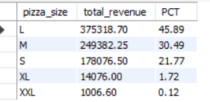

F. Total Pizzas Sold by Pizza Category
SELECT pizza_category, SUM(quantity) as Total_Quantity_Sold
FROM pizza_sales
WHERE MONTH(STR_TO_DATE(order_date,’%d-%m-%Y’)) = 2
GROUP BY pizza_category
ORDER BY Total_Quantity_Sold DESC

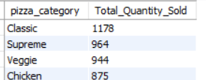

H. Bottom 5 Pizzas by Revenue
SELECT pizza_name, SUM(total_price) AS Total_Revenue
FROM pizza_sales
GROUP BY pizza_name
ORDER BY Total_Revenue ASC
LIMIT 5;
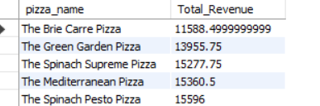

I. Top 5 Pizzas by Quantity
SELECT pizza_name, SUM(quantity) AS Total_Pizza_Sold
FROM pizza_sales
GROUP BY pizza_name
ORDER BY Total_Pizza_Sold DESC
LIMIT 5;
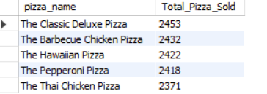

J. Bottom 5 Pizzas by Quantity
SELECT pizza_name, SUM(quantity) AS Total_Pizza_Sold
FROM pizza_sales
GROUP BY pizza_name
ORDER BY Total_Pizza_Sold ASC
LIMIT 5;

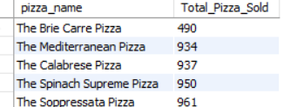
K. Top 5 Pizzas by Total Orders
SELECT pizza_name, COUNT(DISTINCT order_id) AS Total_Orders
FROM pizza_sales
GROUP BY pizza_name
ORDER BY Total_Orders DESC
LIMIT 5;
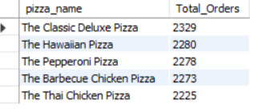

L. Borrom 5 Pizzas by Total Orders
SELECT pizza_name, COUNT(DISTINCT order_id) AS Total_Orders
FROM pizza_sales
GROUP BY pizza_name
ORDER BY Total_Orders ASC
LIMIT 5;
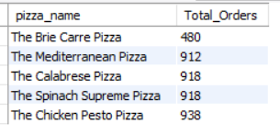

NOTE
If you want to apply the pizza_category or pizza_size filters to the above queries you can use WHERE clause. Follow some of below examples
SELECT pizza_name, COUNT(DISTINCT order_id) AS Total_Orders
FROM pizza_sales
WHERE pizza_category = 'Classic'
GROUP BY pizza_name
ORDER BY Total_Orders ASC
LIMIT 5;

